Imperialism: *THE JUNGLE BOOK*

**20 Point**

**Quiz**

**Background:**

Rudyard Kipling wrote the famous children’s book, *The Jungle Book* in 1893. It was written at the height of British imperialism around the globe. Kipling is known for his great pride in Britain and his support of British imperialism. Many of his written works portray this in his characters. *The Jungle Book* is no exception. The story is set in the jungle of India. Although it is a children’s book, the characters symbolize much of what Kipling believed was right about the British colonization of India.

**Assignment:**

How do the characters in the movie, *The Jungle Book*, reflect the actions and intentions of British imperialism in India in the 19th century?

* Pay attention to the messages given by each character and how they each may symbolize elements of imperialism.
* Submit a response written in brief paragraph form. There is no specific format or length requirement, but be sure to accurately and adequately answer the question.

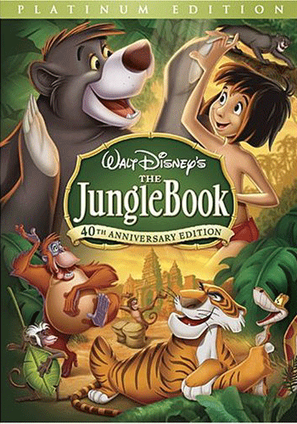I have listed the characters you may want to focus on the most. You may want to take some notes on them while you watch, but be sure to enjoy the film.

* Mowgli
* King Louie
* Baloo
* Kaa
* Shere Khan
* Colonel Hathi
* Bagheera
* Vultures